**10031873@mail.tycg.gov.tw**

**寄件者:** Sister Cities International <info@sistercities.org>

**寄件日期:** 2025年2月14日星期五 下午 9:00

**收件者:** 10031873@mail.tycg.gov.tw

**主旨:** SCI - 2025 Young Artists and Authors Showcase

**郵件標幟: 標幟狀態:**

待處理

已標幟

Email not showing up correctly? View this email in your browser



1

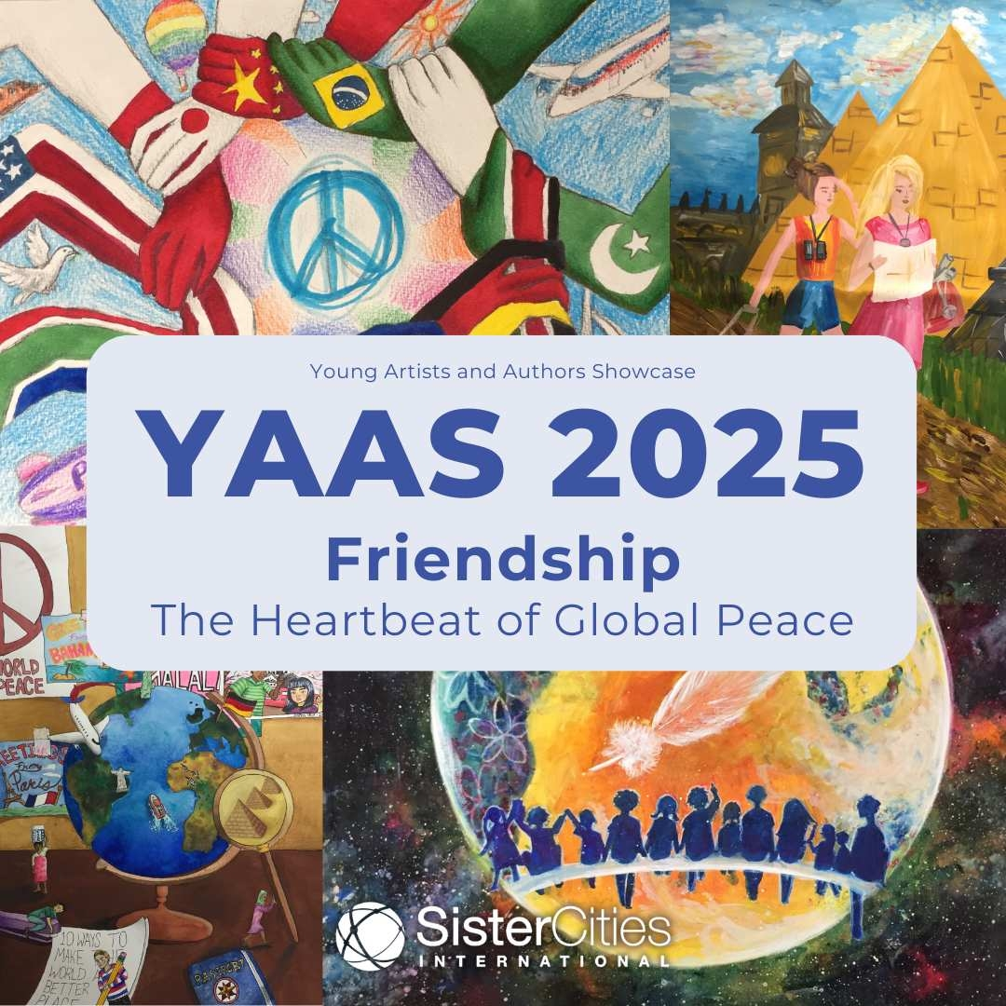

**DEADLINE TO APPLY: APRIL 1, 2025**

Sister Cities International is proud to present the 2025 Young Artists and

Authors Showcase, inviting youth from around the world to express their

creativity through the theme **“Friendship: The Heartbeat of Global**

**Peace.”** This year’s theme highlights the **power of friendship to foster**

**understanding**, **collaboration**, and **peace across borders.**

By participating in this inspiring competition, young creators will have the opportunity to share their vision of a peaceful world and contribute to the

international dialogue about the importance of building friendships across

nations. Winning entries will be featured in Sister Cities International’s global

network, inspiring communities and leaders worldwide.

**VISIT OUR WEBSITE FOR MORE**

**INFORMATION**

This year, we are hosting two separate competitions based on age groups. Applicants aged 12-14 will compete in one showcase, while those aged 15-18

will compete in another. In each age group and each art medium, there will be a

first, second, and third place winner.

**CLICK HERE TO APPLY**

Awards will be given out to YAAS winners who place 1st, 2nd, and 3rd place in

each category and in each age showcase.

**1st Place: $1,000**

1. **Place: $500**
2. **Place: $250**

2

**VIEW 2024 WINNERS**



*Copyright © 2025 Sister Cities International, All rights reserved.*

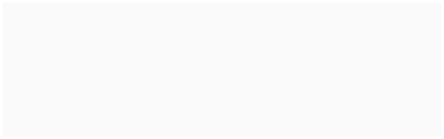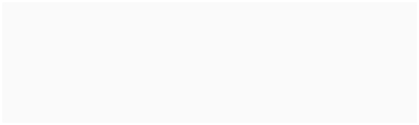

**Our mailing address is:**



1012 14th Street NW Suite 1400



Washington, DC 20005

Want to change how you receive these emails?



You can update your preferences or unsubscribe from this list.



3



SCI YAAS 2025 來信翻譯

青少年藝術家及作家展演（YAAS）2025 友誼－全球和平脈動

截止日期：2025年4月1日

國際姊妹協會很榮幸為您介紹 2025 年青少年藝術家及作家展演徵獎活動，

邀請全球青少年以「友誼－全球和平脈動」為主題展現其創意。今年主題強調以友誼促進跨國界的理解、合作及和平的力量。透過參與本次鼓舞人心的競賽，年輕創作者將有機會分享他們對和平世界的願景，並為建立跨國友誼重要性的國際對話做出貢獻。獲獎作品將在國際姐妹市協會的全球網絡中展出，以啟發世界各地的社區與領導者。

今年，我們將根據年齡組別舉辦兩項獨立的競賽。12-14 歲的申請者將參加

1 組展演活動，而 15-18 歲的申請者將參加另1 組。在每個年齡組別及每項藝術競賽類別中，都將產生第1、第2及第3名獲獎者。

我們將頒獎予每項類別及每個年齡層展演活動中，獲得第1、第2及第3名的參與者。

第1名：1,000美元

第2名：500美元

第3名：250美元